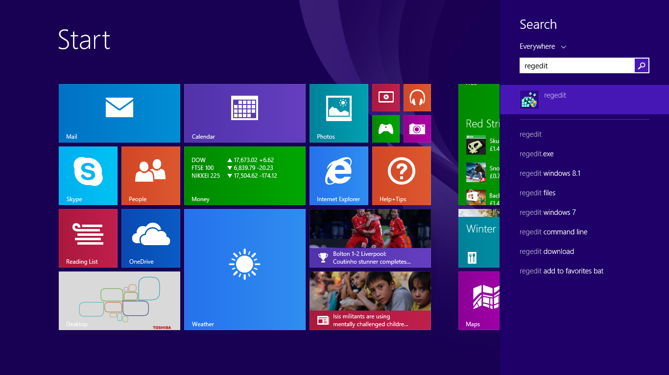

The pop up sign comes up and click yes

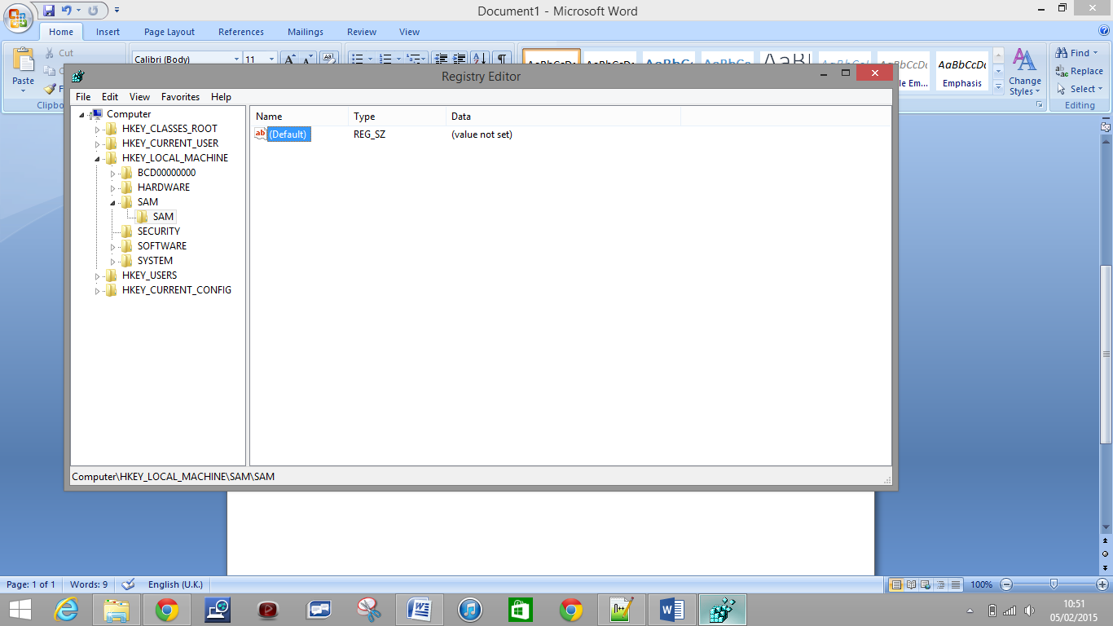

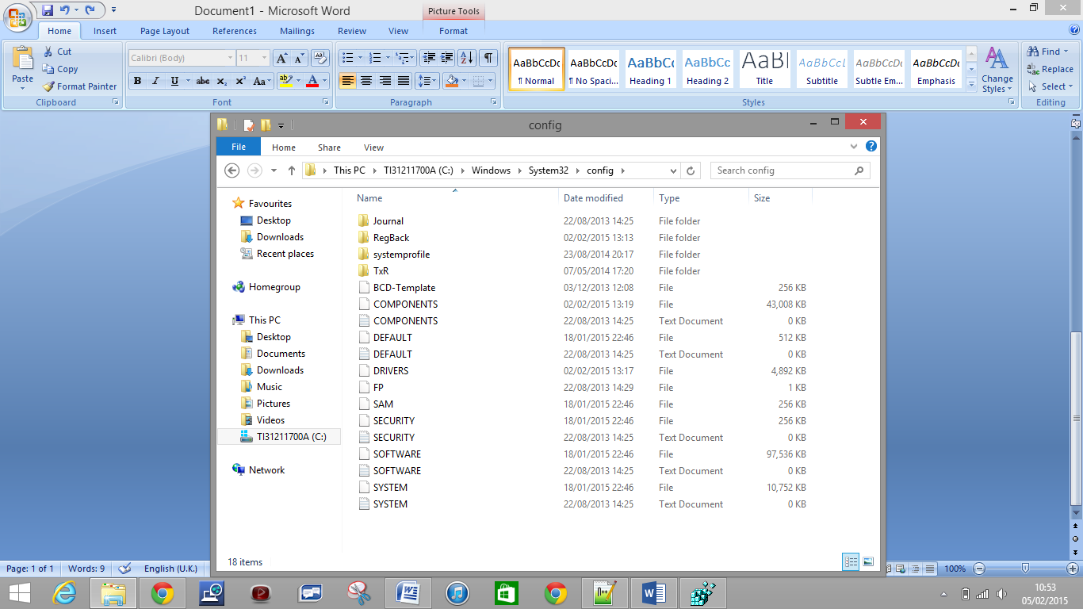

<http://security.stackexchange.com/questions/63890/does-windows-have-a-built-in-password-store>